Computer keyboard key explanations
Updated: 04/09/2024 by Computer Hope
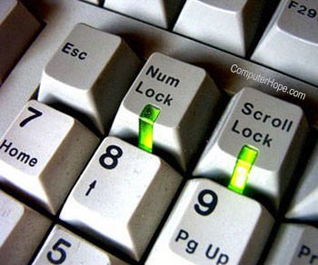
When dealing with technical commands that use a keyboard (for example, web pages or the command line), you may hear such things as forward slash, backslash, and caret. Often, these terms can confuse new users because they're unfamiliar with them.
This page provides an example of a PC keyboard and a table listing non-alphanumeric keys for US-based keyboards, with a description or link for additional information.
Note
For information on keyboard shortcut combinations (e.g., Ctrl+S or Alt+F4), see our computer keyboard shortcuts page.

Example of a keyboard
Below is a close-up image of a QWERTY computer keyboard with each of the keys selectable. Hover your mouse cursor over any key to see a description. Clicking any of the keys opens a new page with full details.
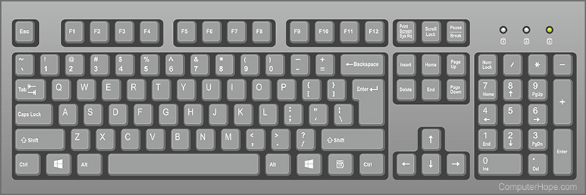

Listing of non-alphanumeric keys
Key/symbol | Explanation
Windows | PC keyboards have a Windows key that looks like a four-pane, wavy window.
Command | Apple Mac computers have a Command with a symbol resembling a cloverleaf.
Copilot | AI PC keyboard key on Microsoft keyboards that activates Copilot.
Menu | PC keyboards also have a Menu key that looks like a cursor pointing to a menu.
Esc | Esc (escape) key.
F1 - F12 | What are the F1 through F12 keys?
F13 - F24 | Information about the F13 through F24 keyboard keys.
Tab | Tab key.
Caps lock | Caps lock key.
Shift | Shift key.
Ctrl | Control key.
Fn | Function key.
Alt | Alternate key (PC only).
Option | Option key (Apple only).
Spacebar | Spacebar key.
Arrows | Up, down, left, right Arrow keys.
Back Space | Back space (or Backspace) key.
Delete | Delete or Del key.
Enter | Enter key.
Prt Scrn | Print Screen key.
Scroll Lock | Scroll Lock key.
Pause | Pause key.
Break | Break key.
Insert | Insert key.
Home | Home key.
Page up | Page up or pg up key.
Page down | Page down or pg dn key.
End | End key.
Num Lock | Num Lock key.
~ | Tilde.
` | Acute, back quote, grave, grave accent, left quote, open quote, or a push.
! | Exclamation mark, exclamation point, or bang.
@ | Ampersat, arobase, asperand, at, or at symbol.
# | Octothorpe, number, pound, sharp, or hash.
£ | Pound Sterling or Pound symbol.
€ | Euro.
$ | Dollar sign or generic currency.
¢ | Cent sign.
¥ | Chinese/Japanese Yuan.
§ | Micro or section.
% | Percent.
° | Degree.
^ | Caret or circumflex.
& | Ampersand, epershand, or and symbol.
* | Asterisk, mathematical multiplication symbol, and sometimes called a star.
( | Open or left parenthesis.
) | Close or right parenthesis.
- | Hyphen, minus, or dash.
_ | Underscore.
+ | Plus.
= | Equal.
{ | Open brace, squiggly brackets, or curly bracket.
} | Close brace, squiggly brackets, or curly bracket.
[ | Open bracket.
] | Closed bracket.
| | Pipe, or, or vertical bar.
\ | Backslash or reverse solidus.
/ | Forward slash, solidus, virgule, whack, and mathematical division symbol.
: | Colon.
; | Semicolon.
" | Quote, quotation mark, or inverted commas.
' | Apostrophe or single quote.
< | Less than or angle brackets.
> | Greater than or angle brackets.
, | Comma.
. | Period, dot, or full stop.
? | Question mark.

Listing of alphanumeric keys
In addition to the keys mentioned above, U.S. keyboards also have the following letter and number keys. These may be used with other modifier keys for keyboard shortcuts.

Letters
A  B  C  D  E  F  G | H  I  J  K  L  M  N | O  P  Q  R  S  T  U | V  W  X  Y  Z

Numbers
- Zero (0)
- One (1)
- Two (2)
- Three (3)
- Four (4)
- Five (5)
- Six (6)
- Seven (7)
- Eight (8)
- Nine (9)
- Ten (10)

